AIM: To create a hotel order app.

PROCEDURE:

- Create the Required Layouts
Design the necessary screens such as:
  - Home Page
  - Menu Page
  - Order Page
  - Payment Page
  - Confirmation Page
- Add the Required Texts
Insert appropriate headings, menu items, prices, buttons (e.g., Order Now, Add to Cart, Pay Now), and other necessary labels.
- Select Appropriate Colors, Fonts, and Font Sizes
  - Choose attractive and readable color combinations.
  - Use suitable fonts for headings and body text.
  - Adjust font sizes for clarity and visual hierarchy.
- Connect the Screens Using Prototype
Link buttons and text elements to their respective layouts using the prototype feature to enable navigation between screens.
- Add Images Wherever Needed
Insert relevant images such as:
  - Food items
  - Hotel logo
  - Background images
- Preview the Application
Finally, view the complete design in Desktop Preview Mode to check functionality and appearance.
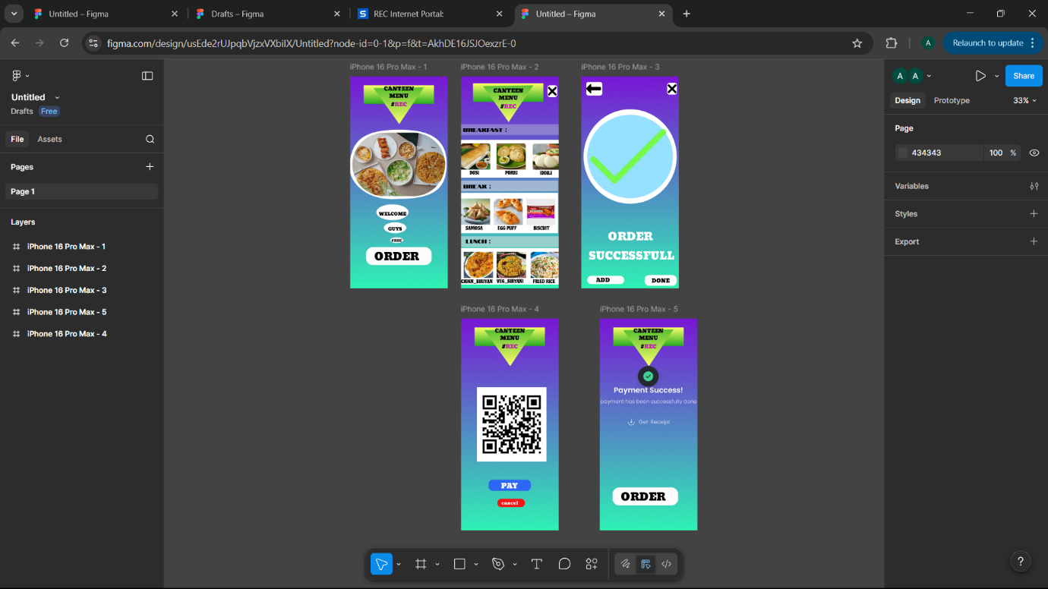

RESULT: Hence the design is completed and output is verified.

